INTRODUCTION
Head Start is an innovative federal program that began in 1964. The overall goal is to improve the social competence of low-income children by increasing everyday effectiveness in dealing with both present and future life responsibilities. This goal is to be achieved through the implementation of a comprehensive child development program that would provide for the physical, social, emotional and intellectual growth of the children.
Every three years, the Head Start regulations require each grantee to conduct a Community Assessment. This report is done to assist the tri-county Head Start/Early Head Start Program in making decisions in regards to program options, classroom locations and potential Head Start families’ recruitment.

GIS AND THE COMMUNITY ASSESSMENT
The community assessment contains several maps created with a Geographic Information System. A Geographic Information System or GIS is defined by the USGS as a computer system capable of assembling, storing, manipulating, and displaying geographically referenced information. GIS stores geographic information in a series of thematic layers that can be linked together by physical location. The primary purpose of a GIS is to process spatial or geographically referenced information. The most common representation of spatial information is a map on which the location of any landmark, such as a Head Start/Early Head Start Facility, could be given using its latitude and longitude.
This map, with a point showing the location of the Head Start /Early Head Start Facility, is not just a static picture. Associated with the point are tables of information about that particular Head Start/Early Head Start Facility. Information like the number of children served, childcare services offered, and personnel descriptions can be accessed by just “clicking” a courser on the point on the map. Also, information about what is happening around the facility can be determined. Information can be found on where Head Start/Early Head Start families, medical facilities, schools, and employment centers are located in relation to the facility. GIS is quickly becoming an invaluable tool for Head Start/Early Head Start comprehensive planning.

OVERVIEW OF THE TRI-COUNTY SERVICE AREA
The Child Care Resources Inc (CCR), Head Start/Early Head Start service area consists of Levy, Dixie and Gilchrist Counties. The service area is located in the Northwest-central area of the state of Florida (See Figure 1). Alachua and Marion Counties bound it on the east; Taylor County bounds it on the west, Lafayette, Suwannee and Columbia on the north, and Citrus County on the south. The tri-county service area is approximately 1,684,224 acres with 83% (1,389,696) acres of land and with 17% (294,528 acres) of open water (FSA 2001). This open land figure for all purposes is substantially smaller due to the abundance of salt marshes along the coast and freshwater marshes inland (Figures 2 and 3).
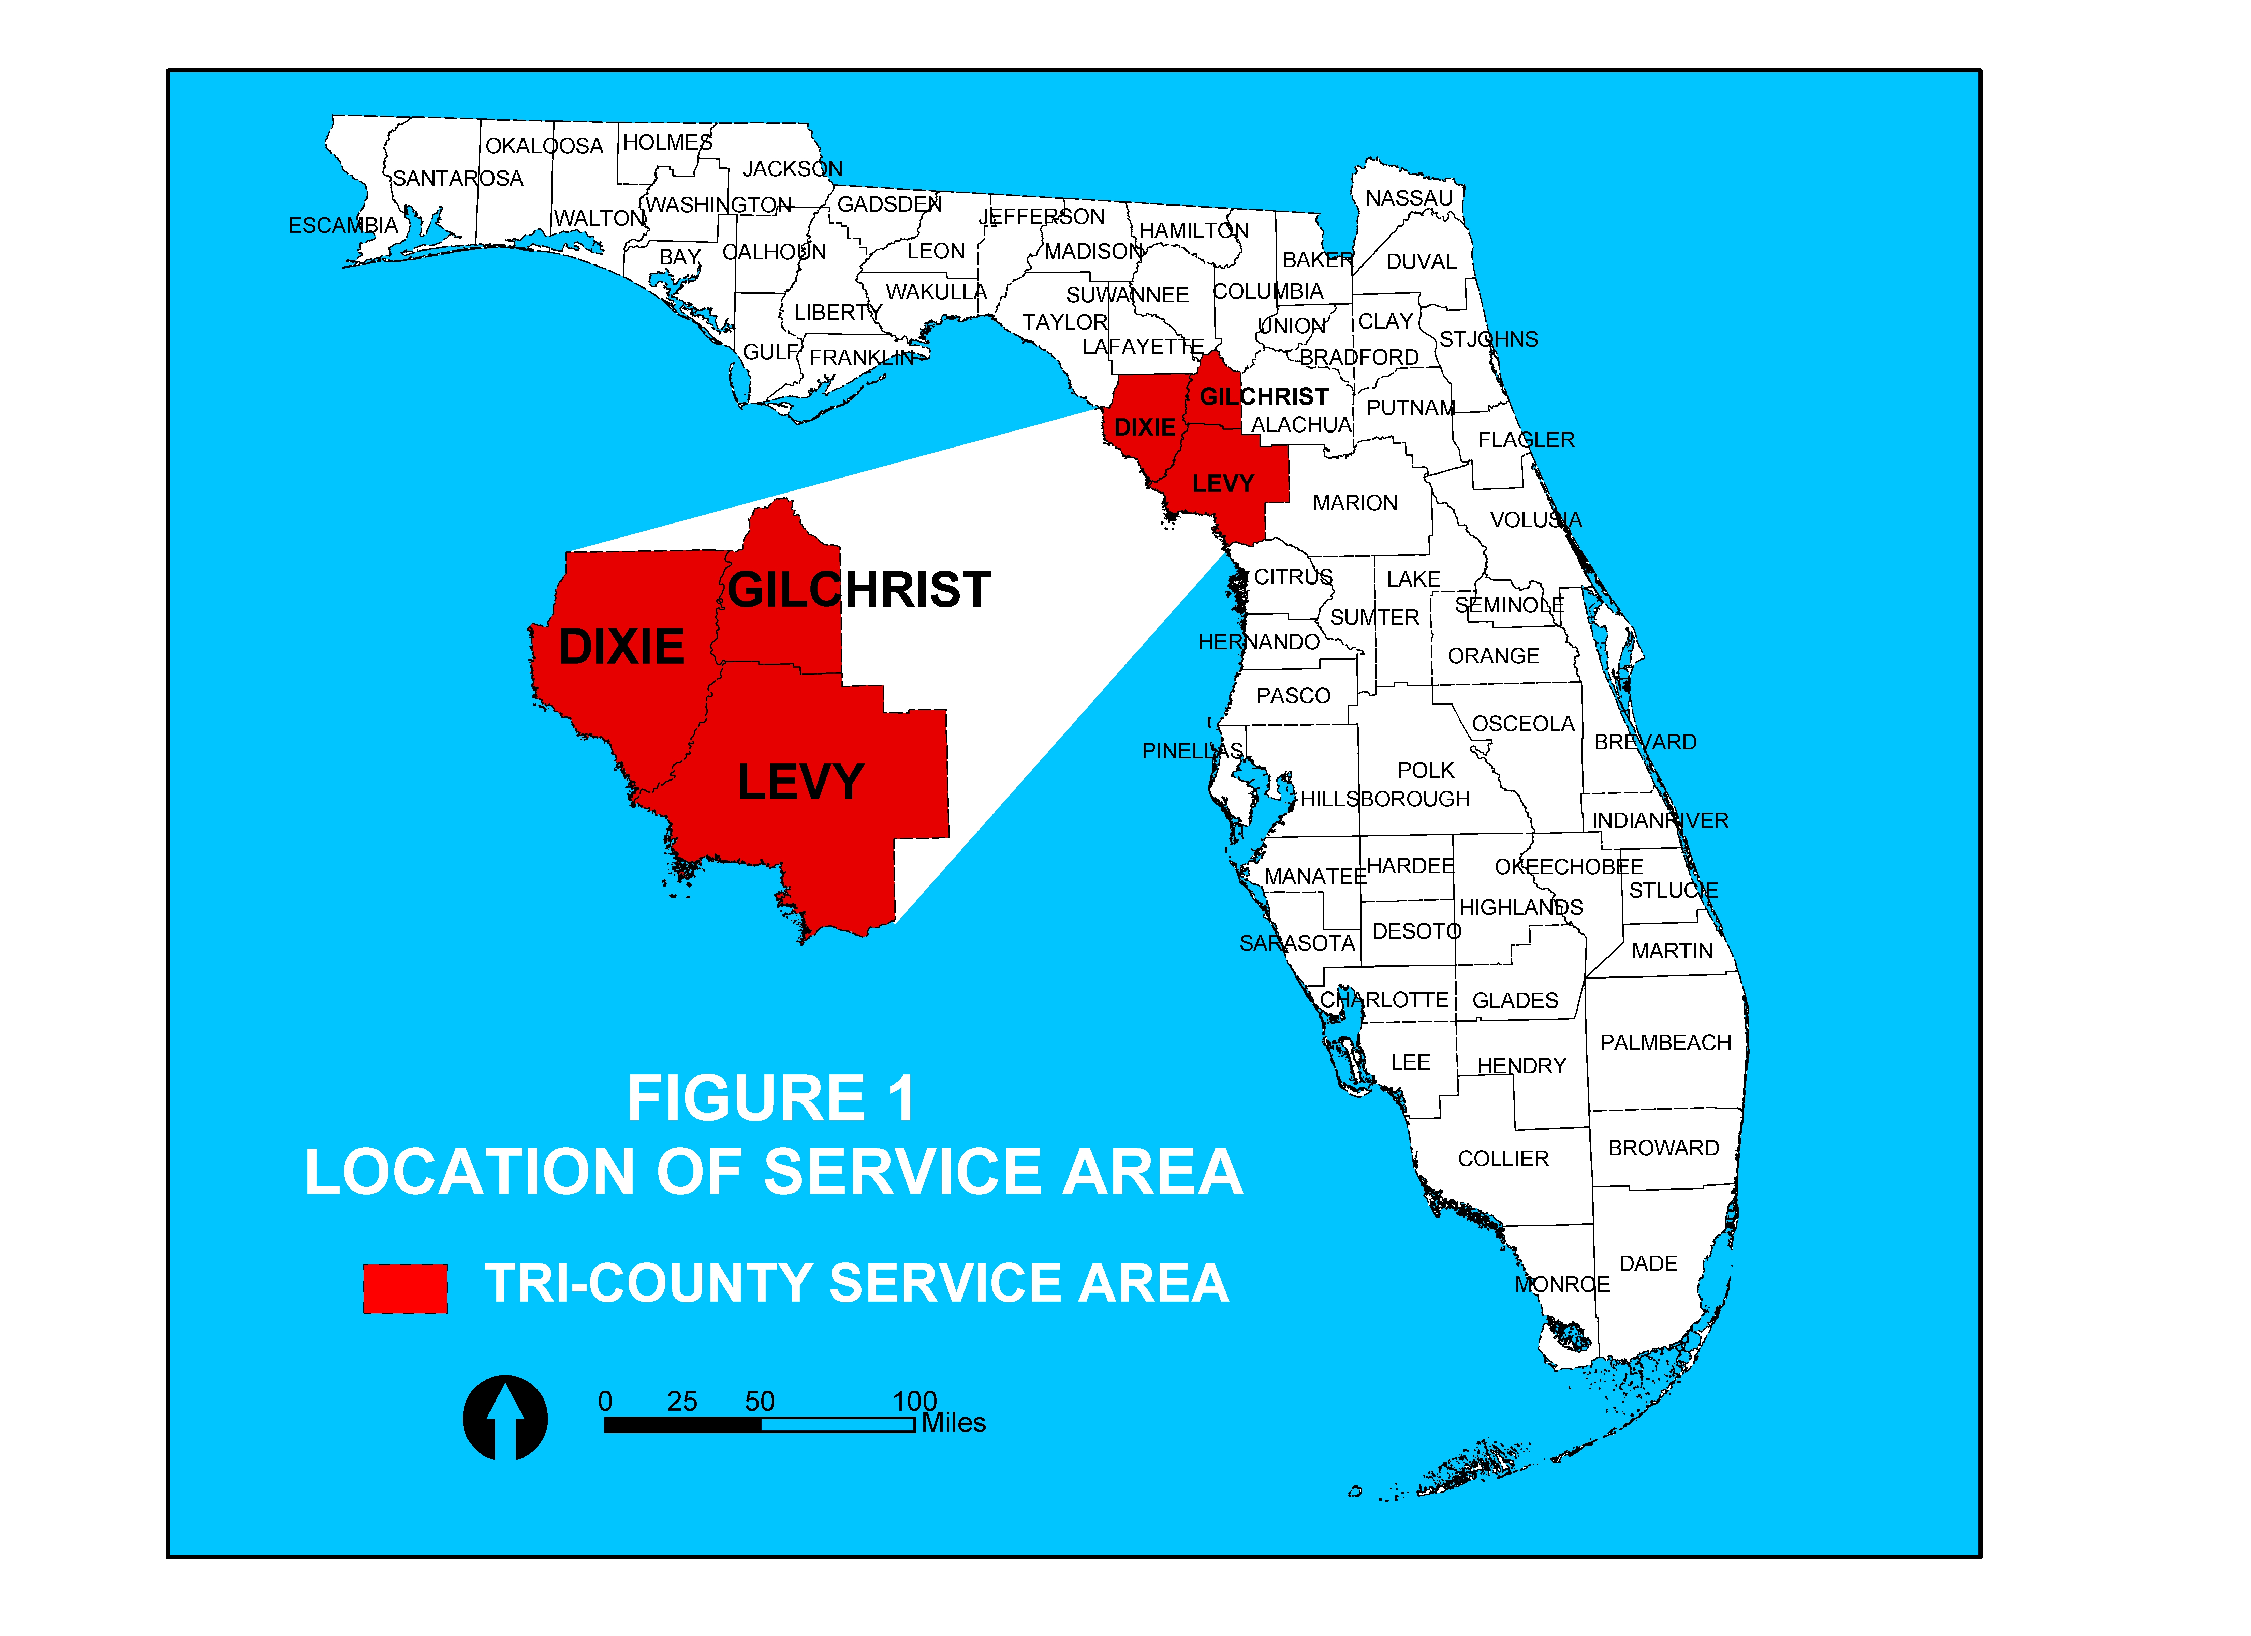
The tri-county area enjoys Florida’s year round mild climate with an average January low of 42° F and an average July high of 91° F. The average yearly rainfall is about 53 inches with a yearly average of 166 rainy days.
The transportation infrastructure in the tri-county area is substantial and growing. The areas three major routes include US19, SR27A-US98 and US129. These highways connect all of the tri-county’s major cities (See Figure 4). Other important roads include US41, SR121, SR24, SR26, SR47, SR349 and SR351. While the tri-county service area is not accessed directly by an interstate or other limited access, high capacity roads, I-75 in Alachua and Marion Counties is under 20 miles from Trenton, Bronson and Williston. US19, along with I-75 serve the tri-county area as important commercial routes (See Figure 4).

Lane expansions are underway for SR27A-US98 between Chiefland, Bronson and Williston and SR26 servicing Fanning Springs, Trenton, Newberry

(Alachua County) and Gainesville (Alachua County) (See Figure 4). These expansions are in response to increased travel and population growth within the area.
The tri-county service area is rich with culture and history. Events such as Red Belly Days, Down Home Days, the Chiefland Watermelon Festival, the Williston Peanut Festival and the Festival of Lights and Boat Parade along with the Cedar Key and Ingles/Yankeetown Seafood Festivals afford visitors and locals many cultural opportunities (Enterprise Florida 2001).
Areas of historical interest include the Cedar Key Museum State Park and Shell Mound State Park containing historic Indian shell mounds. Also of interest are the historic downtown areas of many of the Tri-Counties cities. Cities such as Cedar Key still have that old Florida character.
There are many Recreational opportunities in the tri-county service area. National, state and local parks, public and private campgrounds, lakes and rivers provide affordable leisure-time activities for families. Admission fees for daily use or for overnight camping in these parks are low. The Suwannee River, flowing from Georgia into the Gulf of Mexico, is perhaps the areas most famous landmark made famous in song by Steven Foster.
State parks include Fanning Springs, located on the east bank of the historic Suwannee River in northern Levy County. Fanning Springs is one of Florida’s 27 first magnitude springs, releasing approximately 50 million gallons of water per day. This inviting source of cool, clear water is home to many wildlife species, including otters and the endangered West Indian Manatee. A floodplain

swamp community next to the springs is dominated by bald cypress. Manatee Springs State Park is a 2,373-acre park in Levy County offering excellent swimming and diving. Also located on the bank of the historic Suwannee River, it is one of Florida's premier parks, containing sixteen different ecosystems and a first magnitude spring. The park offers a Junior Rangers program for children ages 6-12. Florida Junior Rangers learn what they can do to help protect Florida’s environmental treasures for future generations.
Cedar Key Scrub State Reserve is a joint managed park consisting of 4,988 acres, with over 12 miles of trails. Also located in Levy County, are Cedar Key National Wildlife refuge and the Cedar Key Museum State Park, which is located on the Florida’s Nature Coast, bordered by the Gulf of Mexico. This area is part of “old” Florida, undisturbed by development and traffic.
Peacock Springs State Park is an outstanding natural ecosystem containing elements of statewide and national significance in a 288-acre recreation area. It is also one of the longest underwater cave systems in the entire continental United States.
Other parks include the Nature Coast Trail State Park, the Lower Suwannee National Wildlife Refuge, Goethe State Forest, Andrews Wildlife Management Area and Waccasassa Bay Preserve State Park.
The area is world renown for its many springs. Fanning, Manatee and Peacock Springs along with Ginnie Springs, Blue Springs, Otter Springs, Devils

Den/Blue Grotto and many others have made the area world famous for its concentration of freshwater springs (See Figure 5). Ginnie Springs was made

world famous when the scuba pioneer Jacques Cousteau paid a visit. These springs and associated rivers are crowded for the majority of the year by canoeists, rafters, tubers and swimmers.
Recreational fishing and hunting opportunities abound in the tri-county with generous public access to the coast and rivers and several conservation areas open to seasonal hunting.
Ample hiking and biking opportunities are also available. The Nature Coast Greenway is nearly 30-mile multi-use trail that connects Cross City in Dixie County to Fanning Springs and Trenton in Gilchrist County and to Chiefland in Levy County. Hikers, bikes, wheelchairs and roller-blades can use this trail.

DEMOGRAPHICS
Table1
1960-2000 Percent Population Change
 | 1960-1970 PERCENT CHANGE | 1970-1980 PERCENT CHANGE | 1980-1990 PERCENT CHANGE | 1990-2000 PERCENT CHANGE
DIXIE | 22.3 | 41.4 | 36.6 | 30.6
GILCHRIST | 23.8 | 62.4 | 67.6 | 49.3
LEVY | 23.1 | 55.8 | 30.4 | 32.9
(Source: 2001 Florida Statistical Abstract)
The total population of the tri-county service area for 2000 was 62,714. This represents a change of 37.6% between 1990 and 2000. Levy County has the largest population with a total of 34,500, Gilchrist is next with a total of 14,437 and Dixie has the lowest population of the three with 13,827. In the past decade, the population in the tri-county service area grew by 37.6% with Dixie growing by 30.6%, Gilchrist by 49.3% and Levy by 32.9% (See Table 1). This is slightly
lower than the previous decade (1980-1990) when the service area grew by nearly 45%. The 37.6% growth experienced in the tri-county service area between 1990-2000 was still considerably greater than the 25.5% occurring statewide.
The Bureau of Economic and Business Research at the University Florida produces population projections for the State of Florida. These values are given as both median and high projections with the actual future population likely to fall somewhere in between (See Table 2). The tri-county area is expected to more
Table 2
Historic Population and 2030 Projections
 | PROJECTION | DIXIE | GILCHRIST | LEVY
1990 |  | 7,800 | 9,700 | 25,900
1995 |  | 12,400 | 11,900 | 29,800
2000 |  | 13,827 | 14,437 | 34,500
2010 | MEDIUM | 16,900 | 18,600 | 42,100
 | HIGH | 21,400 | 23,800 | 51,300
2015 | MEDIUM | 18,400 | 20,800 | 46,000
 | HIGH | 25,300 | 28,800 | 60,200
2020 | MEDIUM | 19,900 | 23,000 | 50,100
 | HIGH | 29,600 | 34,400 | 69,900
2025 | MEDIUM | 21,500 | 25,300 | 54,100
 | HIGH | 34,300 | 40,600 | 80,200
2030 | MEDIUM | 22,900 | 27,300 | 57,700
 | HIGH | 39,100 | 47,100 | 91,100
(Source: 2001 Florida Statistical Abstract)

than double in population in the next 30 years with a medium 2030 population projection of 107,900 and high 2030 projection of 177,300 (FSA 2001). This growth will certainly result in increased need for the services provided by Head Start/Early Head Start. It can be assumed that as long as economic conditions within the tri-county service area remain similar over the next 30 years, the need for Head Start/Early Head Start services will increase by at least 50% as well (See Table 14 in Housing Section).
County population distribution can be seen in Figure 6. This map portrays population densities in the tri-county area. It can be seen that the population is concentrated in northern half of the tri-county area and eastern Levy County. The age structure for the tri-county service area can be seen in Table 3. It can be seen that there are many more children in the 0-14 years age category (6,595 individuals) than that of the 15 to 24-age category (3,905 individuals). This concentration of younger individuals further demonstrates the need for Head Start/Early Head Start services. The lower concentration of individuals ages 15-24 likely the result of migration of high school graduates and other young adults in search of better job opportunities and education outside of the tri-county Area (See Table 3).

Table 3
 | Tri-County Age Structure
 | 0-14 | 15-24 | 25-44 | 45-64 | 65+
DIXIE | 2,460 | 1,690 | 3,683 | 3,625 | 2,369
GILCHRIST | 2,879 | 2,703 | 3,587 | 3,300 | 1,968
LEVY | 6,595 | 3,905 | 8,625 | 9,153 | 6,172
(Source: 2001 Florida Statistical Abstract)

Birth rates for the tri-county service area are very similar to the state average of 13 births per 1,000 individuals. County rates are as follows: Dixie – 11.4, Gilchrist – 13.0 and Levy – 12.5 per 1,000 individuals. The birthrates for tri-

county minorities are substantially different than the state averages of 21.6 for blacks and 21.7 per 1,000 individuals for all other minorities in Gilchrist County. The birthrate for Gilchrist County blacks in 2000 was 1.7 and 33.0 births per 1,000 individuals for all other minorities.
The racial make up of the tri-county service area is 87% white, with less than 10% black and less than 3% Hispanic (FSA 2001). While the percentage of Hispanics in the tri-county service area is significantly lower than that of the state, this trend is expected change to resemble that of the state as the Hispanic population migrates north in search of jobs and better living conditions.

ECONOMIC CONDITIONS
Table 4
Personal Income Earned by Major Economic Sector
 | DIXIE | GILCHRIST | LEVY
SECTOR
FARM EARNINGS | 2,708,000 | 17,420,000 | 37,377,000
NON-FARM EARNINGS | 87,475,000 | 74,541,000 | 217,199,000
PRIVATE EARNINGS | 55,021,000 | 38,495,000 | 154,734,000
FORESTRY, MINING AND FISHERIES | 1,884,000 | 3,269,000 | 10,977,000
CONSTRUCTION | 4,570,000 | 3,281,000 | 24,759,000
MANUFACTURING | N/A | 6,194,000 | 11,590,000
TRANSPORTATION AND PUBLIC UTILITIES | 6,950,000 | 5,420,000 | 14,752,000
WHOLESALE TRADE | N/A | 1,886,000 | N/A
RETAIL TRADE | 7,752,000 | 4,966,000 | 31,190,000
FINANCE, INSURANCE AND REAL ESTATE | 1,565,000 | 1,278,000 | 8,880
SERVICES | 9,365,000 | 12,402,000 | 35,772,000
GOVERNMENT | 32,448,000 | 33,749,000 | 57,622,000
Source: Florida Department of Labor and Employment Security
The tri-county service area is predominately rural in character and this is reflected in its economic characteristics. Relatively large portions of the annual earnings come from agriculture, forestry, fisheries and mining (See Table 4). Also, little of the total annual earnings for the three counties come from wholesale trade, manufacturing or real estate when compared to the nearby and more urban Alachua and Marion Counties. This is indicative of rural counties.
Government services, retail trade and service industry employees dominate the occupational distribution in the tri-county service area (See Table 5 and Chart 1). The area’s large number of workers in retail and service industries is indicative of rural Florida. Average per capita income for the tri-county area is substantially lower ($16,680) than that of the State ($27,781) and the lack of diverse employment opportunities and well paying jobs limits the workforce to unskilled individuals (See Table 6). Head Start/Early Head Start is working on reversing this trend with community outreach and job creation within a community development cooperation approach. Head Start/Early Head Start partners with businesses and local government to enhance economic development throughout the service area. An example of this is an incubator type service that is inclusive of all the makings of establishing a small business. Business incubation is a process of business enterprise development that nurtures young firms, helping them to survive and grow during the start-up period, when they are most vulnerable. Incubators can provide hands-on management assistance, access to financing and exposure to critical business or technical support services. They also offer shared office services, access to equipment, flexible leases and expandable space – usually under one roof.
Head Start/Early Head Start is using Self Sufficiency Benchmarks to set income and standard of living goals to guide these community development efforts.
Table 5
Tri-County Occupational Distribution
 | TOTAL EMPLOYMENT | DIXIE EMPLOYMENT | GILCHRIST EMPLOYMENT | LEVY EMPLOYMENT
AGRICULTURE | 6.5% | 0.7% | 10.5% | 7.0%
CONSTRUCTION | 7.1% | 3.3% | 1.6% | 10.1%
MANUFACTURING | 9.3% | 21.4% | 7.2% | 5.4%
TRANSPORTATION, COMMUNICATION AND PUBLIC UTILITIES | 3.6% | 4.4% | 1.0% | 4.1%
WHOLESALE TRADE | 2.7% | 2.5% | 2.9% | 2.7%
RETAIL TRADE | 21.1% | 16.3% | 11.9% | 25.4%
FINANCE, INSURANCE AND REAL ESTATE | 2.5% | 1.8% | 1.3% | 3.1%
SERVICES | 14.7% | 7.8% | 18.5% | 15.6%
GOVERNMENT | 32.5% | 40.6% | 44.9% | 24.8%
(Source: Florida Department of Labor and Employment Security)
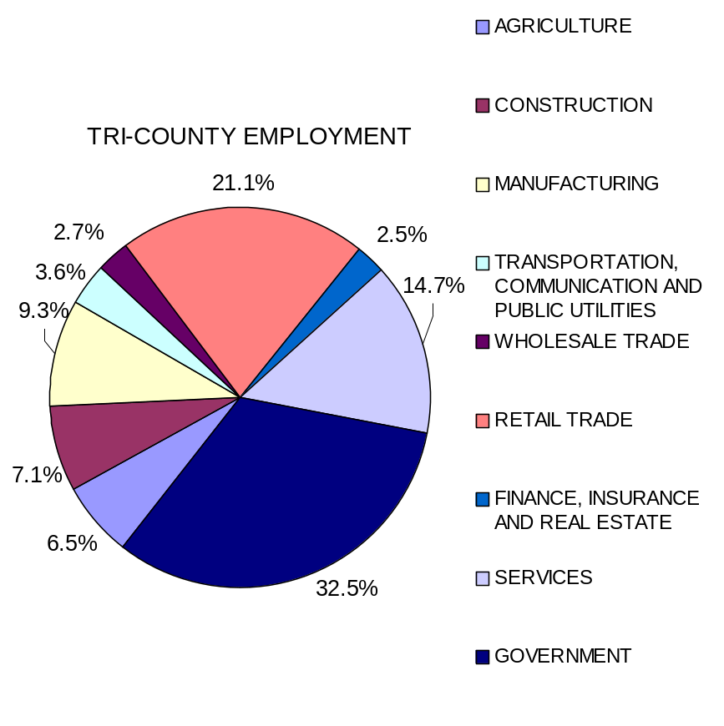
Graph 1
Major Economic Sectors
There are 37 major employers in the tri-county service area. Major employers employ at least 25 individuals (See Table 7). The individual county school boards are the largest employers for each county. The other large employers include the Department of Corrections (Lancaster and Cross City Correctional Institutions), health care providers, and timber and construction companies. These major employers are predominately clustered around the incorporated areas for each county (See Figure 7). This map shows the employer locations identified by numbers that correspond to the Map# field in Table 6.
Table 6
Tri-County Service Area Per Capita Income
 | 1997 | 1998 | 1999
FLORIDA | 25,721 | 26,931 | 27,781
DIXIE | 14,153 | 14,947 | 15,321
GILCHRIST | 15,071 | 15,992 | 16,416
LEVY | 17,142 | 17,841 | 18,305
(Source: 2002 Florida Statistical Abstract)
While the tri-county area’s economy is rapidly growing, many of the area’s workers travel outside of the area to work. Of the Tri-Counties workers 16 years old and older, nearly 50% travel outside their county of residence for work(See Table 8). While they could be traveling to work within the tri-county service area, the high mean travel times indicate that many of these workers are likely traveling west to Alachua or Marion Counties.
Table 7
Tri-County Service Area Major Employers
MAP # | DIXIE | NUMBER OF PEOPLE EMPLOYED
1 | DIXIE COUNTY SCHOOL BOARD | 330
2 | CROSS CITY CORRECTIONAL INSTITUTION | 313
3 | SUWANNEE LUMBER CO | 180
4 | ANDERSON COLUMBIA CONSTRUCTION | 150
5 | GEORGIA PACIFIC CORP | 110
6 | DIXIE COUNTY | 79
7 | CROSS CITY REHABILITATION | 84
8 | KNIGHT'S SAWMILL | 81
9 | CROSS CITY VENEER CO | 65
10 | RICK’S SEAFOOD | 35
11 | SUWANNEE RIVER ECONOMIC COUNCIL | 25
 | GILCHRIST
12 | GILCHRIST COUNTY SCHOOL BOARD | 427
13 | LANCASTER CORRECTIONAL INSTITUTION | 332
14 | AYERS HEALTH AND REHABILITATION CENTER | 135
15 | NORTH FLORIDA HOLSTEINS | 110
16 | TRI-COUNTY HEALTH CENTER | 78
17 | GILCHRIST COUNTY COMMISSION | 79
18 | ALLIANCE DAIRY | 70
19 | KINCAID PRODUCTS | 60
20 | AURORA DAIRY UNIT 3 | 60
21 | HILLTOP DAIRY FARMS | 55
22 | AQUAPENN WATER CO | 50
23 | GENNIE SPRINGS RESORT | 35
24 | BELL CONCRETE | 28
25 | NEW DAWN FUTON | 27
 | LEVY
26 | LEVY COUNTY SCHOOL BOARD | 829
27 | WAL-MART | 450
28 | MONTEREY BOATS | 316
29 | OAKVIEW REHABILITATION / CARE CENTER | 145
30 | BOARD OF COUNTY COMMISSIONERS | 213
31 | DAB CONSTRUCTION | 150
32 | LEVY COUNTY SERIFF'S OFFICE | 130
33 | A&N CORP | 95
34 | CENTRAL FLORIDA ELECTRIC COOPERATIVE | 97
35 | WINN-DIXIE | 90
36 | V.E. WHITEHURST | 76
37 | NATURE COAST REGIONAL HOSPITAL | 100
(Source: Florida Department of Labor and Employment Security)

Table 8
Mean Travel Time and Percent Working Outside of County of Residence
 | WORKERS 16 YEARS AND OVER
 | MEAN TRAVEL TIME TO WORK (MINUTES) | PERCENT WORKING OUTSIDE COUNTY OF RESIDENCE
FLORIDA | 26.2 | 18.1
DIXIE | 30.2 | 37.4
GILCHRIST | 33.5 | 59.8
LEVY | 31.4 | 46.4
(Source: US Census 2000 Website)

Although most of the areas in the tri-county are rural and undeveloped, the economy in the tri-county service area is still growing. The future development will concentrate on the major cities of the service area. This will create more job opportunities. With the lane expansions along SR27A and the possibility of a major Wal-Mart distribution center locating either within the tri-county service area or in the nearby city of Alachua in Alachua County, the economic future of the tri-county area is very promising.

POPULATION LIVING IN POVERTY
Most Head Start/Early Head Start eligible families are living in poverty. The average percentage of people living in poverty in the tri-county service area is 17.3% which is higher than the state average of 12.5% but less than the 1997 tri-county average of 20.9% (US CENSUS 2002). The average percentage of children aged 0-4 living in poverty in the tri-county area is about 22% (given that 790 children aged 0-4 live in poverty out of the tri-county total of 3572 children aged 0-4) (See Table 9). This figure is higher than the state average of 18% of children ages 0-4 living in poverty. Head Start/Early Head Start recently received expansion of funds to serve an additional 50 eligible pregnant women, infants and toddlers residing in the tri-county service area. This small amount is beneficial but continued efforts are needed to offset the overall problem of living in poverty.

Table 9
Children Aged 0-4 In Poverty
 | POPULATION OF CHILDREN AGED 0-4 | POPULATION OF CHILDREN AGED 0-4 IN POVERTY
DIXIE | 770 | 136
GILCHREST | 827 | 119
LEVY | 1975 | 535
TOTAL | 3572 | 790
(Source: 2000 US Census Website)

Among the factors that contribute to poverty of the 0-4 population is the large number of children born to teenage mothers (See Table 10). The total for the tri-county service area (19.07% of all births) is substantially higher than those of the State (12.48% of all births). These mothers usually have limited education and poor occupational skills.
To address the problems of teenage mothers in the tri-county area Head Start/Early Head Start has partnered with Even Start/TAPS (Teen Age Parent Services) in Dixie and Gilchrist Counties and the TAPS in Levy County. Head Start/Early Head Start provides comprehensive family services for teen parents to allow completion of their high school education.
Female-headed families often encounter hardships not felt by families with two parents. These hardships stem from inability of a single parent to fill the
Table 10
Births To Mothers Under Age 20
 | TOTAL BIRTHS TO MOTHERS UNDER AGE 20 | PERCENT OF ALL BIRTHS
FLORIDA | 25,664 | 12.58
DIXIE | 38 | 23.90
GILCHRIST | 29 | 16.02
LEVY | 80 | 18.56
TOTAL | 147 | 19.07
(Source: 2001 Florida Statistical Abstract)

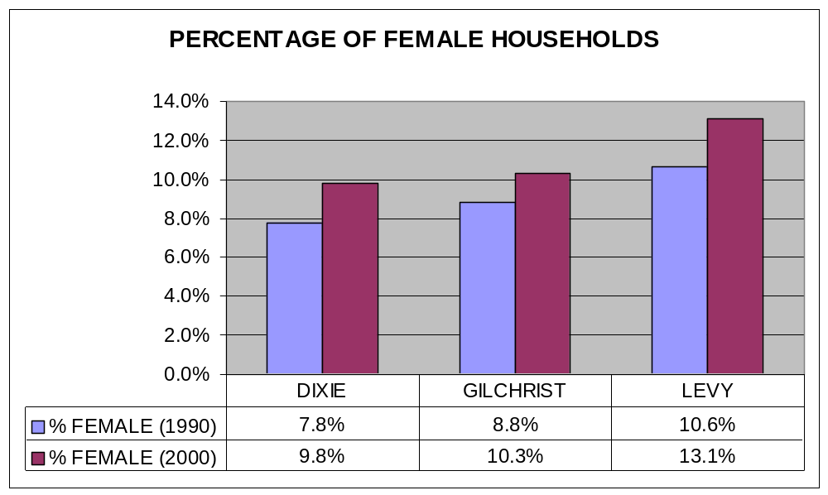roles of wage earner and childcare provider. The 2000 Census Data revealed that an average of 11.1% of families in the tri-county are female-headed households. This is only a slight increase from 1990 where the total was 9.1% (See Graph 1).
Graph 2
Percentage of Female Households
(Source: 1990 and 2000 US Census Website)
To address the problems encountered with single parent households Head Start/Early Head Start, through its C’MMAND (Committed Males Making A Needed Difference) program, has partnered with the following funding sources to engage both the custodial and non-custodial father in his child’s life: Workforce Development Boards, the Florida Commission on Responsible Fatherhood, Child Support Enforcement and the Region IV Head Start/Early Head Start Fatherhood/Early Literacy Initiative. The benefits are additional income within the child’s home and the support of the father as a role model.

CHILDREN WITH DISABILITIES
Disabilities services available within the Tri County area include services provided by the school districts, community and private agencies. School districts provide physical therapy, occupational therapy, social work services, profoundly mentally handicapped, educable mentally handicapped, emotionally handicapped, trainable mentally handicapped, visually impaired, physically impaired, autistic, specific learning disabilities, developmentally delayed, speech/language impaired and evaluation services. Community providers include the Developmental, Evaluation & Intervention Program at the University of Florida, Department of Pediatrics (Part C) Program, which serves birth to 36 months. It provides a comprehensive, multidiscipline, community-based, family-focused program that ensures a coordinated system of early intervention services for infants and toddlers with special needs. DEI provides multidisciplinary developmental evaluations to determine eligibility and the development of a plan for intervention. The program also provides Service Coordination, the Family Support Planning process; facilitation of transition and coordination of required services. The Developmental, Evaluation & Intervention Program reports a caseload of 53 children identified with developmental delays ages 0-3 years old for Dec 2002 (See Table 11). This figure represents a fraction of the need of those identified with developmental delays.
Table 11
Part C/ DEI Caseload 2002
 | 2002
DIXIE | 11
GILCHRIST | 14
LEVY | 28
(Source: Developmental, Evaluation & Intervention Program)

The kinds of special needs served range from children who are generally “at risk” for developmental delay due to birth circumstances (such as prematurity) to children with established conditions that have been shown to put them at risk for developmental delay to children with confirmed developmental delay.
Head Start/Early Head Start partners with DEI for doing referrals, in providing the coordination of services for the children and families served, in any training offered and in the writing of the Family Support Plan for children eligible for services. Head Start/ Early Head Start and DEI also coordinate transition planning and promote community awareness for both programs.
Head Start/ Early Head Start partners with each local school district in the tri-county service area for referrals, in any training that is offered, screenings, evaluations, parental permission and the IEP (Individual Education Plan) process.

CHILD CARE PROGRAMS
Childcare is primary barrier to employment for both single parents and families living in poverty. The elimination of AFDC rapidly created a new pool of workers seeking employment and in turn led to an increased demand for childcare. Work requirements under the new welfare reform programs have not only created an increased demand for childcare but also increased the total time children spend in care, resulting in a critical need for full day/year round services. The Head Start/Early Head Start program has increased 50% of its service delivery system of year round/full day services.
According to a national survey, more than 40% of respondents reported that they had been terminated or quit jobs/training programs or withdrew from school due to difficulties with childcare, noting that inconsistent or fluctuating work schedules were conflicting with consistent child care. This statistic is likely to be dramatically higher in light of current world events, especially the 9-11 tragedy. In Florida, TANF changed eligibility for state-subsidized childcare and the cost of care to participants. Pre-kindergarten families experienced a change from free services to an assessed fee based on family income. Caps have been placed on subsidized childcare services since early 2001 resulting in an extensive wait list for families in need of childcare.
To increase the number of providers, provisions for unregulated care/relative care were introduced. This could result in lower-quality childcare for participants. If programs require co-payments that vary with the cost of care, parents will have an incentive to place children in lower cost, possibly lower quality care. Thus, the issue of ensuring access to high quality care for these mothers becomes one of the most critical concerns in the success of the new welfare reform. Studies show that good, formal care has the potential to significantly contribute to a child’s school readiness for success. Early childhood programs of relatively high quality have been found to improve a child’s social, psychological and cognitive readiness for school and they are associated with long-term success including higher school achievement. Incentives for achieving high quality childcare have encouraged some programs to achieve accreditation levels of service: NAEYC (National Association for the Education of Young Children, APPLE (Accredited Professional Preschool Learning Environment).
In 1999 the Florida Legislature created the Florida partnership for school readiness for purposes of administering the school readiness programs (below Kindergarten age). The Legislature recognizes that school readiness programs increase children’s chances for achieving future educational success and becoming a productive member of society. It is the intent that such programs be developmentally appropriate, research-based, involve parents as their child’s first teacher, serve as preventative measures for children at risk of future school failure, enhance the educational readiness of eligible children and support family education. Each school readiness program shall provide the elements necessary to prepare at-risk children for school, including health screenings and referrals and appropriate educational programs.
The intent of the legislature is that all early educational and child care programs funded with state, federal, lottery or local funds shall be components of the local coalitions integrated school readiness programs with the goal of preparing children for success in school. CCR’s agency director and HS/EHS director are members of the Dixie, Gilchrist, and Levy School Readiness Coalition. Several HS/EHS staff members and other CCR agency staff also serve on various committees.
The need is great for available, affordable and accessible childcare services within the tri-county service area. Currently the Head Start/Early Head Start program is serving 324 eligible Head Start children and families in the tri-county service area (See Figure 8). Of the 3572 children aged 0-4 in the tri-county area, 790 are below the poverty level and thus likely to be eligible for Head Start/Early Head Start services.
Table 12
Childcare Services Provided
 | EARLY HEADSTART | HEADSTART | PREGNANT | PRE-K EI | PRE-K DIS | SUBSIDIZED | WAITLIST
DIXIE | 16 | 37 | 6 | 54 | 71 | 487
GILCHRIST | 0 | 40 | 0 | 52 | 55 | 184
LEVY | 32 | 191 | 2 | 92 | 60 | 74
TOTALS | 48 | 268 | 8 | 198 | 186 | 708 | 28
(Source: Head Start/Early Head Start Documents)

Of the 708 children receiving early childhood services throughout the tri-county service area, 324 are being serviced by the Head Start/Early Head Start Program (See Table 12).
Head Start has established partnerships with the following child care facilities to provide both Head Start and Early Head Start throughout its tri-county service area:
- Planet Recess – Bronson, Levy County

- White Rose Nursery – Williston, Levy County
- Kid N Company – Williston, Levy County
- Clyatt House Learning Center – Chiefland, Levy County
- Oliver Family Resource Center – Cross City, Dixie County
Other partnerships include:
- Gilchrist County School Board (Bell Elementary and Trenton Elementary) (New Early Head Start expansion – Even Start / Teen Parent Program)
- Levy County School Board (Chiefland Elementary, Bronson Elementary, Joyce Bullock Elementary and Yankeetown School)
Head Start/Early Head Start provides services for 20 non-Head Start eligible low-income families and eligible school aged children at the Oliver Family Resource Center located at Cross City, Dixie County, Florida.
Head Start/Early Head Start has recently received expansion of funds to serve an additional 50 eligible pregnant women, infants and toddlers residing in the tri-county service area.
The current management systems approach established for the delivery of services to children and families will be expanded to integrate the addition of the 50 new Early Head Start eligible pregnant women, infants & toddlers. The Head Start/Early Head Start management system functions are described as:
The administrative level (governing bodies, administrative staff) assures policies/procedures are developed, quality services are delivered and programmatic and fiscal functions are accountable. At the management level service area managers and area coordinators perform the overall coordination of service delivery to children and families, ongoing monitoring and follow-up of comprehensive services. At the service delivery level and support services level the staff performs the direct service delivery to all enrolled children and families. This systematic approach functions through teams organized by service area.

HOUSING
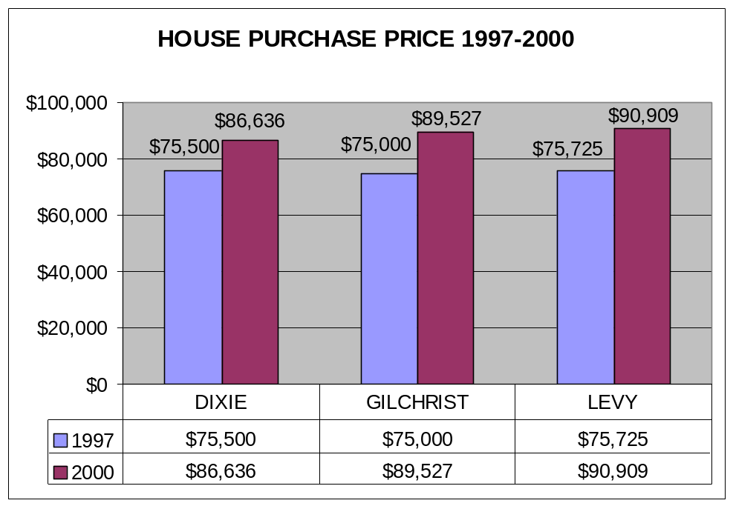The average sales price of a home in Dixie County in 2000 was $86,636. This is a 14.7% increase from the average 1997 price. The average price for a home in Gilchrist County in 2000 was $89,527, a 19% increase from 1997. Levy experienced the greatest change in home costs with a 2000 average price of $90,909, an increase of 20% from 1997 (See graph 3).
Graph 3
House Purchase Price 1997-2000
(Source: 1990 and 2000 Census)
While the average house price appears to be relatively high, over half of the population lives in low priced “homes” not captured in this statistic. Nearly 50% of the housing units in the tri-county service area are mobile homes (See table 13). This reflects high level of poverty witnessed in this highly rural area.

Table 13
Units in Structure
 | DIXIE | GILCHRIST | LEVY | FLORIDA
TOTAL UNITS | 7,362 | 5,906 | 16,570 | 7,302,947
1-UNIT, DETATCHED | 40.6% | 40.3% | 42.7% | 52.3%
1-UNIT, ATTATCHED | 8.0% | 0.4% | 1.4% | 5.9%
2 UNITS | 5.0% | 0.4% | 1.3% | 2.7%
3 OR 4 UNITS | 6.0% | 0.5% | 1.1% | 4.3%
5 TO 9 UNITS | 1.0% | 0.5% | 0.9% | 5.0%
10 TO 19 UNITS | 0.0% | 0.1% | 0.0% | 5.0%
20 OR MORE UNITS | 2.0% | 0.2% | 0.5% | 12.9%
MOBILE HOME | 54.1% | 57.0% | 51.5% | 11.6%
BOAT, RV, VAN, ETC | 2.9% | 0.6% | 0.6% | 0.4%
(Source: 2000 US Census)

The average rent price for the tri-county service area in 2000 was $285, which was lower than the statewide average (See graph 4).
The average median household income in the tri-county service area is $27,800 (See table 14). This makes it hard for people to own their own homes pushing them to purchase lower value and often lower quality homes or mobile homes. The tri-county’s Housing Authority provides low-income, public housing and rental assistance for the tri-county residents through “Section 8” rental units. The waiting list is usually 3 to 5 years and the beginning of the WAGES (Work and Gain Economic Self-sufficiency) welfare program will make it even more difficult to get in.
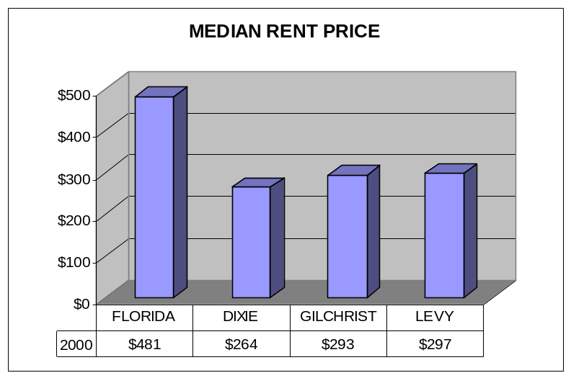One of the long-term goals of the HS/EHS program is in the area of community development with an emphasis on coordinating stakeholders (Builders, Empowerment and Enterprise agencies, and local municipalities) for the purpose of developing affordable communities.
Graph 4
MEDIAN RENT PRICE
(Source: 2000 Census)
Table 14
Median Household Income
 | MEDIAN INCOME (DOLLARS)
FLORIDA | 1,952,629
DIXIE | 2,428
GILCHREST | 1,844
LEVY | 6,263
(Source: 2000 US Census Website)

TRANSPORTATION
According to the National Survey, the segment of the Nation’s population that most critically needs basic community services is the same segment that tends to have the least physical access to these services. A large number of Head Start/Early Head Start families have transportation problems. The greater length of time spent in transit, the less amount of time spent with their children in either the practical tasks of parenting or in the provision of intimate care taking needed by young children for their social and emotional development. In addition, greater travel time may require the use of multiple caregivers if the time away is greater than the hours of care available by any one child care provider. Those who have automobiles suffer from a major malady; poor people generally own poor cars. They are too old and inadequate for long-distance commuting and expressway operation and they are usually uninsured. All these have made it difficult for families to get quality childcare and good jobs.
While the tri-county’s major arterials tend to be well maintained, many of the roads servicing residential areas are often not as well maintained and often unpaved and in poor condition. This is especially true in Dixie County where much of the residential housing is mobile homes serviced by unpaved and poorly maintained roads. Unpaved and poorly maintained roads service many of the Head Start/Early Head Start families. This creates a hardship for the Head Start/Early Head Start program impacting staff use of vehicles for coordination of services. In addition, poor roads limit the transportation of Head Start/Early Head Start families to and from program services. This in turn imposes a financial hardship on the Head Start/Early Head Start budget.
Public Transportation is virtually non-existent in the tri-county area with an average of only 0.4% of workers 16 years old and older using transportation (See Table 15). Local government needs to address this critical hardship that directly affects Head Start/Early Head Start families.

Table 15
Workers Using Public Transportation
 | PERCENT WORKERS 16 AND OLDER USING PUBLIC TANSPORTATION
FLORIDA | 1.9
DIXIE | 0.3
GILCHRIST | 0.7
LEVY | 0.2
(Source: 2001 Florida Statistical Abstract)

One solution might be to contract with local transportation companies to provide transit services to the poor and disabled in the isolated rural areas. Several attempts have been made to tackle this problem, including alternate work routes and school bus shuttles. The CTC (Community Transportation Coordinator), a state designated specialized transportation coordinator for Dixie, Gilchrist and Levy counties arranges door-to-door van and car service for those who cannot access or do not have regular bus service. Medicaid recipients may receive transportation for approved medical treatments with advance reservations and the TD (Transportation Disadvantaged) program offers services to those who are disabled, elderly or low income and not eligible for other sponsored programs. The TD rider pays between 10 to 25% of the actual cost except in Levy County, where the cost is $1.50 per person one-way.

EDUCATION
Table 16
School Enrollment and Educational Attainment
 | DIXIE | GILCHRIST | LEVY | FLORIDA
SCHOOL ENROLLMENT
TOTAL | 2,814 | 3,574 | 7,753 | 3,933,279
PRESCHOOL | 106 | 175 | 520 | 271,313
KINDERGARTEN | 162 | 214 | 453 | 212,744
GRADE 1-4 | 723 | 798 | 1,881 | 853,528
GRADE 5-8 | 756 | 918 | 2,059 | 863,463
GRADE 9-12 | 709 | 1,038 | 1,910 | 845,406
COLLEGE, UNDERGRADUATE | 320 | 403 | 857 | 741,013
COLLEGE, GRADUATE OR PROFESSIONAL SCHOOL | 38 | 28 | 73 | 145,812
EDUCATIONAL ATTAINMENT (PERCENT OF POPULATION)
LESS THAN 5TH GRADE | 1.5 | 0.9 | 1.2 | 1.9
5TH TO 8TH GRADE | 9.8 | 7.2 | 5.7 | 4.8
9TH TO 12TH GRADE, NO DIPLOMA | 22.8 | 19.8 | 18.9 | 13.4
HIGH SCHOOL GRADUATE | 39.4 | 36.1 | 38.2 | 28.7
SOME COLLEGE, LESS THAN ONE YEAR | 7 | 8.2 | 8.7 | 7.5
1 OR MORE YEARS OF COLLEGE, NO DEGREE | 9.5 | 13.1 | 11.5 | 14.3
ASSOCIATE DEGREE | 3.2 | 5.6 | 4.9 | 7
BACHELOR'S DEGREE | 3.7 | 6.3 | 6.9 | 14.3
MASTER'S DEGREE | 1.8 | 2.1 | 2.4 | 5
PROFESSIONAL DEGREE | 0.7 | 0.9 | 1 | 2.3
DOCTORATE DEGREE | 0.5 | 0 | 0.4 | 0.8
HIGH SCHOOL GRADUATE OR HIGHER | 65.9 | 72.4 | 73.9 | 79.9
BACHELOR"S DEGREE OR HIGHER | 6.8 | 9.4 | 10.6 | 22.3
(Source: 2000 US Census)
The educational profile of the tri-county service area in 2000 relates that 7.6% of individuals 25 years older within the tri-county have less than 9th grade attainment, 37.9% have a high school diploma and 8.9% have a bachelor’s degree or higher (See Table 16). In the tri-county area the percent of individuals with a High School Diploma is higher than the State average but the percentage with a bachelor’s degree or higher is substantially lower (22.3% for the State vs 8.9% for the tri-county area. This is a result of lack of institutions of higher learning located in the area. High School graduates have limited resources available to further their education that include satellite centers through Lake City community college in Cross City, Dixie County, and Central Florida Community College located in Chiefland, Levy County. The University of Florida is a minimum of 40 miles away from the tri-county area but does attract some of the area’s high school graduates. Marion has course offerings through St. Leo and Nova Colleges.
Head Start/Early Head Start participates with the Region IV Florida professional development initiative for developing collaborative partnerships with the State’s universities and colleges. The purpose is to enhance the offering of accredited degree programs within the unserved communities including the tri-county locale. This is a long-term effort that needs continued support to succeed.
Head Start/Early Head Start is working with participants through the C’MMAND program and parent training activities such as the GED, computer literacy, family literacy, early childhood development and vocational programs.
Of the 324 families that received Head Start/Early Head Start services throughout the tri-county service area, there are approximately 183 adults 18 years and older who have attained high school diploma or GED, and 51 adults who have attained education beyond the high school level and 108 adults who have less than a High school education (See table 17).
The North Central Florida Regional Planning Council and Withlacooche Planning Council provide the data that documents the needs for employment and training of the tri-county service area. Furthermore, LCCC (Lake City Community
Table 17
Educational Attainment of Head Start/Early Head Start Families
 | LESS THAN HIGH SCHOOL | HIGH SCHOOL  OR GED | SOME COLLEGE | COLLEGE GRADUATE
TRI-COUNTY | 108 | 183 | 47 | 4
(Source: Head Start Documents)

College. Lake City, FL), SFCC (Santa Fe Community College. Gainesville, FL), CFCC (Central Florida Community College. Chiefland, FL) and TTI (Taylor Technical Institute. Perry, FL) are also available for academic and vocational/technical trainings and advancement.

SOCIAL SERVICES
AFDC & TANF
In the Fiscal year 1995-1996, there were 2951 average monthly cases and 1121 families receiving AFDC (Aid to Families with Dependent Children) payment within tri-county service area. In 1996-1997, after the WAGES program took effect in Florida, AFDC changed to TANF (Temporary Aid to Needy Families). Two years later, in the 1999-2000, this number dropped even further to 829 cases with 376 families receiving AFDC payment (See Table 18).
In coordination with the State’s move toward welfare reform for dependent families, the Head Start/Early Head Start program is providing further assistance through its individualized family partnership agreement. Referrals are made for families to Even Start in Dixie and Gilchrist for their GEDs. In Levy County GED

Table 18
AFDC in 1995 through 2000
 | DIXIE | GILCHRIST | LEVY | TOTAL
AFDC (1995-1996 FISCAL YEAR)
AVERAGE MONTHLY EXPENDITURES | $81,971 | $50,054 | $148,695 | $280,720
ASSISTANCE GROUPS (FAMILIES) | 325 | 201 | 595 | 1,121
AVERAGE MONTHLY CASES | 865 | 537 | 1,549 | 2,951
AFDC (1999-2000 FISCAL YEAR)
AVERAGE MONTHLY EXPENDITURES | $26,546 | $14,147 | $49,385 | $90,078
ASSISTANCE GROUPS (FAMILIES) | 108 | 59 | 209 | 376
AVERAGE MONTHLY CASES | 250 | 126 | 453 | 829
(Source: 2000 US Census)

referrals are made to CFCC (Central Florida Community College). Head Start/Early Head Start assists families in getting their CDA (Child Development Associate Certification), State Childcare Certification, CPR and First Aid training. Families are referred to a variety of other agencies within our service area for job skill training, outreach assistance and emergencies.
More families in need of services would benefit if legislation for reauthorization of the Head Start/Early Head Start Act of 2003 changes over income guidelines from 10% to 25% over income eligible families.

MEDICAID
In the Fiscal year 2000, there were 11,473 residents within the tri-county service area receiving $35,060,606 in Medicaid funds (See Table 19). This is up from 1998 where 10,498 residents received $24,943,210 in Medicaid funds. Families are referred to healthy kids for their health coverage needs.

Table 19
Medicaid 2000
 | RECIPIENTS |  | EXPENDITURE
 | 1998 | 2000 | 1998 | 2000
FLORIDA | 1,957,632 | 1,943,819 | $5,631,068,510 | $6,907,099,979
DIXIE | 2,842 | 3,040 | $5,030,877 | $8,510,320
GILCHRIST | 2,065 | 2,769 | $6,461,027 | $9,307,874
LEVY | 5,591 | 5,664 | $13,451,306 | $17,242,412
(Source: 2001 Florida Statistical Abstract)

FOOD STAMPS
As of 1999, 5,905 tri-county residents received Food Stamps. This is a reduction from the 1997 Food Stamp recipient total of 6415. Families receiving food stamps usually meet the criteria for Head Start / Early Head Start eligibility (See table 20).
Table 20
Food Stamps 2000
 | RECIPIENTS |  | BENEFITS
 | 1997 | 1999 | 1997 | 1999
FLORIDA | 1,034,852 | 912,351 | $74,148,000 | $18,275,000
DIXIE | 1,945 | 1,693 | $128,000 | $111,000
GILCHRIST | 1,095 | 1,067 | $69,000 | $71,000
LEVY | 3,375 | 3,145 | $219,000 | $206,000
(Source: 2001 Florida Statistical Abstract)

SSI
The total number of clients received SSI in the tri-county area to children 18 and under as of 1999 was 310. This is up from 281 children receiving SSI in 1997 (See Table 21).

Table 21
SSI Income Recipients 1997 and 1999 (18 years and under)
 | DIXIE | GILCHRIST | LEVY | FLORIDA
1997 | 72 | 54 | 155 | 57,590
1999 | 96 | 48 | 166 | 64,561
CHANGE | 25% | -13% | 7% | 11%
(Source: 2001 Florida Statistical Abstract)

HEALTH
INFANT HEALTH
Of particular interest to the Head Start program is the health of the children under the age of 5.
Babies with low birth weight are those born weighting less than 5.5 pounds. Low birth weight babies are 40 times more likely to die during the first year. Those who survive face increased risk of mental retardation, cerebral palsy, learning difficulties, and behavioral problems. The percent low birth weight is high in Gilchrist County and Levy County in relation to the State (See Table 22).
Table 22
Percent Low Birth Weight
 | 1998 | 1999 | 2000 | 2001
DIXIE | 4.55% | 8.79% | 5.66% | 6.98%
GILCHRIST | 7.10% | 6.37% | 11.05% | 9.30%
LEVY | 9.16% | 5.35% | 9.51% | 9.97%
FLORIDA | 8.08% | 8.19% | 7.98% | 8.17%
(Soure: Florida Department of Health, Public Health Indicators Data System (P.H.I.D.S.))

Here, the problem of infant mortality must be addressed. “To achieve further reductions in infant mortality and morbidity, health care providers and individuals must focus on modifying the behaviors and lifestyles that affect birth outcomes. For example, they should identify health problems before pregnancy, such as smoking, substance abuse, poor nutrition and short pregnancy intervals” (Healthy People 2000, 1999). Infant mortality in the tri-county area is very low with a 2001 infant death rate of 3.7 compared to the statewide rate of 7.8 (Vital Records and Statistics 2002). This can be attributed to the efforts of programs such as Early Head Start, Healthy Start, Even Start, WIC, Public Health Programs and teen parenthood programs.
MENTAL HEALTH
Meridian Behavioral Healthcare, Inc. and the Henry & Rilla White Foundation, Inc. are two mental health agencies that Head Start/ Early Head Start partners with in the tri-county service area. Both of these agencies have non-profit status. Meridian provides a simple point of entry over the access centerline that is staffed 24 hours a day by a professional. Head Start /Early Head Start children & families also access services this way. This creates a barrier for families to access services. The White Foundation provides family-centered counseling including family systems, peer relations, school interventions, community networking and problem solving. Head Start/ Early Head Start children and families can be referred directly to the agency for services. However, they are limited by the number of Medicaid approved professionals they have on staff to provide services for pre-school aged children.
Head Start/ Early Head Start also partners with Penny L. Phares ARNP, C.S. for mental health services. Ms. Phares is a private provider with an office located in Yankeetown. She provides counseling services and play therapy to Head Start/ Early Head Start children and families through a contractual agreement.
DENTAL
Survey results from the tri-county area revealed that Fluoride Treatments are not added to the Water system. This in turn causes a lot of dental decay problems for the Head Start children. Dental costs have increased. One solution has been to purchase toothpaste with fluoride in each classroom for daily toothbrush routines.
The dental needs of the Head Start families are being met minimally through the Medicaid program coordinated with Head Start funds that are available for the Head Start enrolled child. For those children who are not Medicaid eligible, a Dental Agreement has been established between University of Florida Pediatric Dentistry and CCR, Inc. Head Start program. A couple of dentists within the service area are also providing the needed dental services for enrolled children at the Medicaid rate.
On the local school campuses basic health and nutrition services are being provided on a regular basis for children attending the school. Care for Head Start families is provided by the Chiefland Medical Center, Williston Pediatrics, Trenton Medical Center in Trenton and Public Health Units in three counties. In addition, the area is served by larger institutions such as the Nature Coast Hospital in Williston, Shands Hospital in Gainesville and Seven Rivers Hospital in Citrus County.

COMMUNITY RESOURCES
- The Florida Department of Children and Families Foster Care Program provides placement in foster homes for children who are abused or neglected and in imminent danger in the home.
- The Division of Blind Services provides medical, social, vocational rehabilitation, children’s services, and home instruction.
- The Meridian Behavioral Health care provides comprehensive mental health and substance abuse services, family and individual therapies.
- Local County Health Departments provide family planning, immunizations, STD testing, primary care, child health care, health information, WIC services.
- Children’s Medical Services (CMS) provides medical services to children under 21 years of age, under 100% poverty, Medicaid eligible and other household with severe medical conditions.
- Child Support Enforcement provides services to any custodial parent seeking child support.
- The Children’s Table provides food for needy families. Delivery is also available.
- United Christian Services of Dixie County provides clothes, food pantry, emergency funds for rent, utilities and medicine.
- Salvation Army provides emergency funds for food, shelter and energy.
- Suwannee River Economic Council provides help with transportation, delinquent bills, weatherization, commodities, and adult literacy.
- SHARE Food Program provides low cost food packages.
Civic Organizations in tri-county service area:
- American Business Women Association
- Rotary Club
- Chiefland Women’s Club
- Tri-County Council for Senior Citizens, Inc.
- Civilian Club
- Tri-County Outreach Program, Inc.
- Kiwanis
- Lions Club
Collaborative Partnerships:
- Partnership for A Better Tomorrow
- Fatherhood Initiative – Committed Males Making a Needed Difference (C’MMAND)
- Department of Children and Families Partnership
- Teenage Parent Services
- Child Care Providers
- Students Working Against Tobacco (SWAT)
- Herry & Rilla White Foundation
- North Central Florida Community Action Agency
- Florida Diagnostic Resources and Learning Systems Interagency Council
- Tri-County School Readiness Coalition (Levy, Gilchrist, Dixie)
- Meridian Behavioral Healthcare
- University of Florida School of Dentistry
- Santa Fa Community College Dental School
- USDA Childcare Food Program
- Levy, Gilchrist and Dixie County School Boards

GRANTEE PHILOSOPHY AND GOALS
Philosophy: The Head Start and Early Head Start programs within Child Care Resources, Inc., are committed to the continued development and expansion of comprehensive, quality childcare. Our comprehensive approach will meet the social, health, education, parental and disability needs of children and their families in the tri-county service area. By building competencies in core areas and by enabling each family to work toward self-sufficiency, families will gain social and emotional well-being and each child will enter Kindergarten ready to learn.
Goal 1: Work toward continuous program improvement to ensure quality childcare with standardized measurement and reporting.
Goal 2: Continue to assess the community needs for quality childcare and plan programs to address those needs.
Goal 3: Establish and maintain computer network and technical support system linking all offices and centers and supporting network systems for professional development.
Goal 4: Continue the collaboration of multiple funding sources toward the enhancement of Head Start and Early Head Start services. New service centers planned for the future are shown in Figure 9.
Goal 5: Continue to expand and improve the delivery of transportation services to Head Start and Early Head Start children and their families.
Goal 6: Support on-going opportunities for all staff to build competencies and upgrade their skills.
Goal 7: Establish strategies to receive accreditation under NAEYC and Program of Achievement.
Goal 8: Continue to implement and expand programs for fatherhood, literacy, community and economic development and other initiatives that support our Head Start and Early Head Start families.
Goal 9: In collaboration with national, regional, state and local organizations, advocate for programs and policies that will improve the service delivery system for our Head Start and Early Head Start families and expand eligibility standards to include the working poor.
Goal 10: Secure new Head Start administrative building in one of the three counties of the service area.
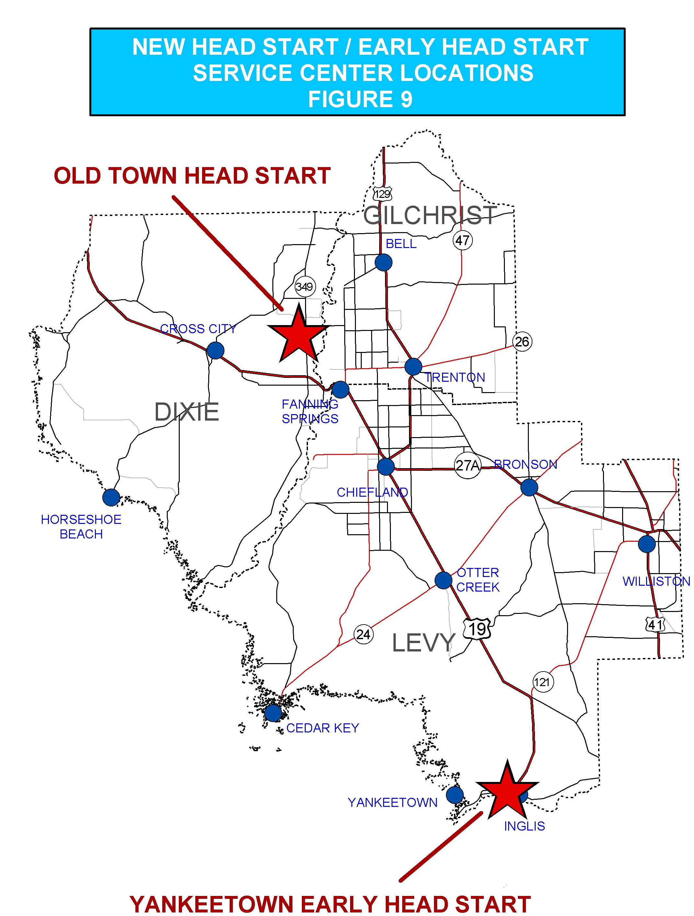

REFERENCES

Bureau of Economic and Business Research(BEBR). 1999 Florida Statistical Abstract (FSA). 2000. University of Florida Warrington College of Business Administration. Gainesville, Fl.

Bureau of Economic and Business Research(BEBR). 2001 Florida Statistical Abstract (FSA). 2002. University of Florida Warrington College of Business Administration. Gainesville, Fl.

U.S. Bureau of the Census. 2000 Census Summary Files 1, 2 and 3. http://www.census.gov 2001-2002. U.S. Department of Commerce. Washington, D.C. Nov 2002 – Jan 2003.

Enterprise Florida Inc. Florida County Profile. http://www.floridabusiness.com Dec 2002

Vital Records and Statistics. Florida Vital Statistics Annual Report 2001. 2002. Office of Vital Statistics, Florida Department of Health.

GeoPlan Center, Department of Urban and Regional Planning, University of Florida. Florida Geographic Data Library (GIS Data). 2002-2003 release.

Tri-County Head Start Division. Community Assessment 1999. 2000. Child Care Resources, Inc. Gainesville, Fl.

