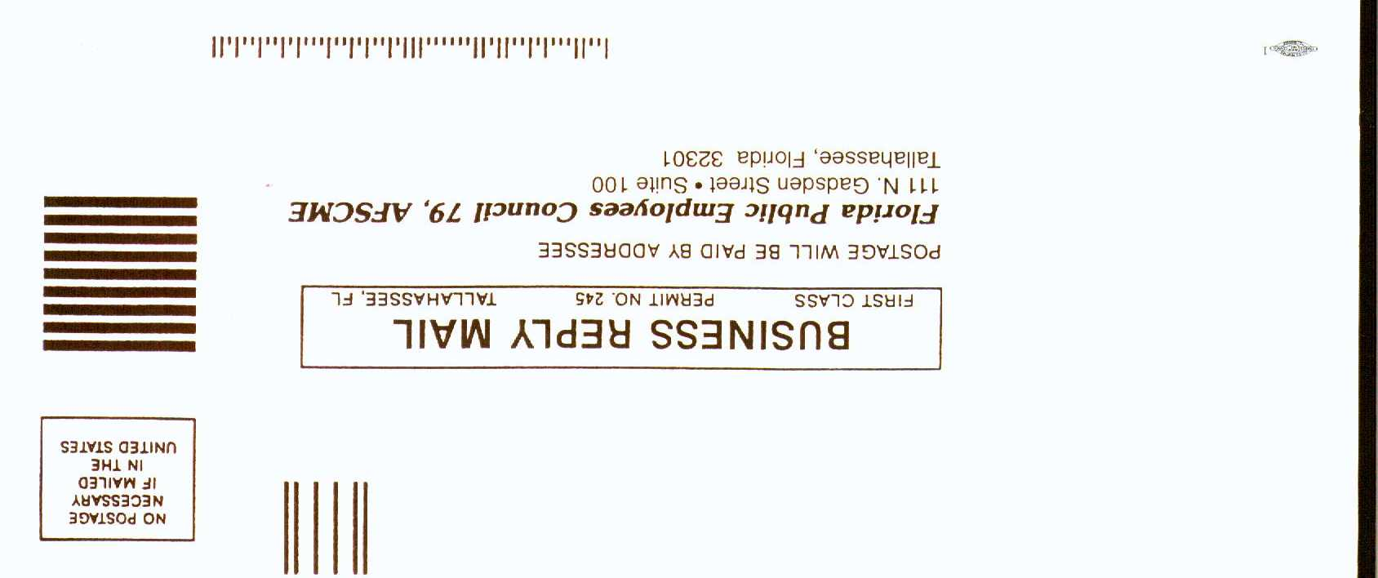

________________________________________________________________________________________________
AFSCME - STATE UNIVERSITY SYSTEM - DUES CHECKOFF AUTHORIZATION
I authorize the Florida Board of Regents, through the university (if applicable), to deduct from my pay, starting with the first full pay period commencing not earlier than seven days from the date this authorization is received by the university (or by the Board for Board office employees), membership dues and assessments and the American Federation of State, County and Municipal Employees as established from time to time by AFSCME in accordance with its constitution, and as certified to the board by AFSCME. Furthermore, I understand that such dues and assessments will be paid to AFSCME.
This authorization shall continue until either (1) revoked by me at any time upon thirty days written notice to the Florida Board of Regents, the university personnel office, and to AFSCME; (2) my transfer or promotion out of an AFSCME represented bargaining unit; (3) termination of employment; or (4) revoked pursuant to Section 447.507, F.S..
Dues Deduction Authorization Cards and Forms "Dues, contributions or gifts to AFSCME are not deductible as charitable contributions for federal income tax purposes. Dues paid to AFSCME, however may qualify as business expenses and may be deductible in limited circumstances subject to various restrictions imposed by the Internal Revenue Service".
By signing this form, I authorize the Board of Regents to release my Social Security number to AFSCME in reporting dues deductions.

_________________________________________________ ______________________________ _________________________________
Signature Date Social Security #

_________________________________________________ ______________________________ _________________________________
University (or BOR) Department or Work Location Job Classification

_________________________________________________ ______________________________ __________________________________
Name Phone Ded Code County Class Local
(Line Above for Union Use Only)
_________________________________________________ ______________________________
Home Address City State Zip

